Git Hub LINK: https://github.com/Shahriar-Ahmed-Dipu/101425451_comp3123_labtest2.git

Dev Screenshot: 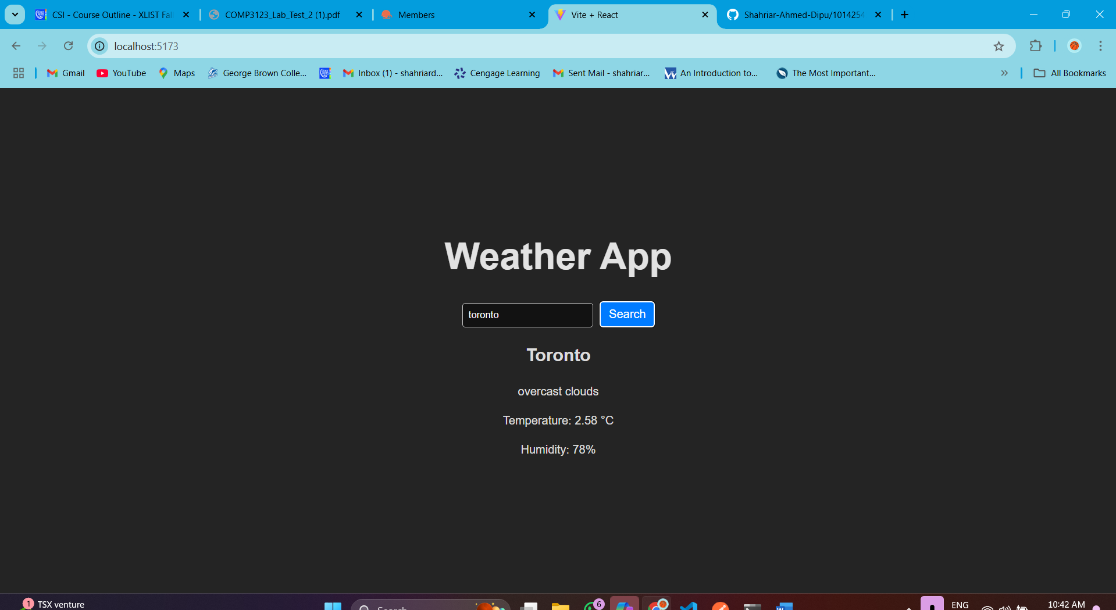

PostMan screenshot
